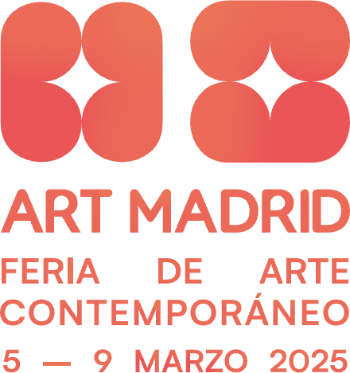

**Press Release - Parallel Program: Territorio Ciudad, Pre-Fair Activities**

# Territorio Ciudad: Experiencing Art Before the Fair

* **The Parallel Program of Art Madrid’25 brings contemporary art to the city with interventions, street micropoetry, and studio visits in the days leading up to its opening.**
* **A preview that invites exploration of how art transforms the urban environment and connects with the public outside conventional spaces.**
* **From artistic actions in the Madrid Metro to encounters with artists, Territorio Ciudad decentralizes art and makes it accessible to everyone.**

*Madrid, February 20, 2025*. In the days before **Art Madrid’25**, the city anticipates the fair with a **Parallel Program** that extends contemporary art into urban spaces. From **February 28 to March 2**, the city will transform into a space of creation and exchange thanks to *Territorio Ciudad*, featuring artistic interventions, urban poetry, and studio visits that offer a dynamic and surprising preview of what awaits at the **Galería de Cristal in the Palacio de Cibeles** starting on **March 5**.

## Art in Motion: The Metro and Streets as a Canvas

The **Madrid Metro** will become a pop-up gallery thanks to *Arquitecturas Imaginadas*. Artists **Ana Matey, Domix Garrido, Araceli López,** and **Andrés Montes** will intervene in Lines 1 and 2, inviting travelers to reflect on art and urban mobility. These interventions aim to surprise passersby, creating an artistic pause amid the city's fast pace. As a result, the stations will transform into spaces for dialogue, where art and everyday life intersect.

Meanwhile, poetry will take over **Plaza de Pedro Zerolo** with *Dialoga Ciudad*, where **Pez Mago, Celia Bsoul, Ajo,** and **Peru Saizprez** will fill the heart of Madrid with verses that break with the routine. This poetic action invites the public to pause and become part of an open dialogue with the city, naturally and intimately integrating art into daily life.

## Encounters with Creation: Studio Visits

*La Quedada* will offer an exclusive glimpse into the creative processes of **Boa Mistura, Todoporlapraxis, C.A.R., Mateo Maté,** and **Laura Lío**, as they open their studios to reveal the art shaping contemporary Madrid. Visitors will have the chance to converse with the artists, explore their inspirations, and witness how ideas materialize into works that dialogue with the urban environment.

This studio tour is not just about unveiling the most intimate side of artistic creation; it also highlights the diversity of approaches and techniques that coexist within today's art scene.

Through this initiative, **Art Madrid’25’s Parallel Program** will not only decentralize art but also bring it closer to the public, offering unique experiences that set the stage for the fair, which will take place from **March 5 to 9**. A **cultural preview** that invites the public to discover how art shapes the city.

For full details on schedules, locations, and participating artists, visit the [official Art Madrid website](https://www.art-madrid.com/).

For additional details about Art Madrid'25 and access to press materials, [click here](https://drive.google.com/drive/folders/1Li1PPmS1NA7Or7xqaHpe-EzOt8cOUoF1?usp=sharing) and please visit: [www.art-madrid.com](http://www.art-madrid.com/)

### About Art Madrid

**Art Madrid**, a leading contemporary art fair, will celebrate 20 years of contemporary art from **March 5 to 9, 2025**, at the **Galería de Cristal in the Palacio de Cibeles in Madrid**. This year, the fair commemorates its **20th anniversary**, solidifying its position as a benchmark in both the national and international art scene. Over the past two decades, it has distinguished itself for its commitment to diversity and the quality of its artistic proposals, attracting over 100,000 visitors in its last five editions.

The Galería de Cristal in the Palacio de Cibeles, with its prime location and excellent accessibility, offers a unique setting that enhances the experience of contemporary art. During the fair, this space transforms into a vibrant meeting point for galleries, collectors, artists, and art enthusiasts from around the world.

In 2025, **Art Madrid** reinforces its mission to promote the art market and collecting both nationally and internationally while fostering cultural dialogue and accessibility. The fair maintains its welcoming spirit and commitment to innovation, positioning itself as an inclusive platform where all audiences can explore the latest trends in contemporary art.